1. Created a new pipeline project slack_demo
2. Installed slack notification plugin

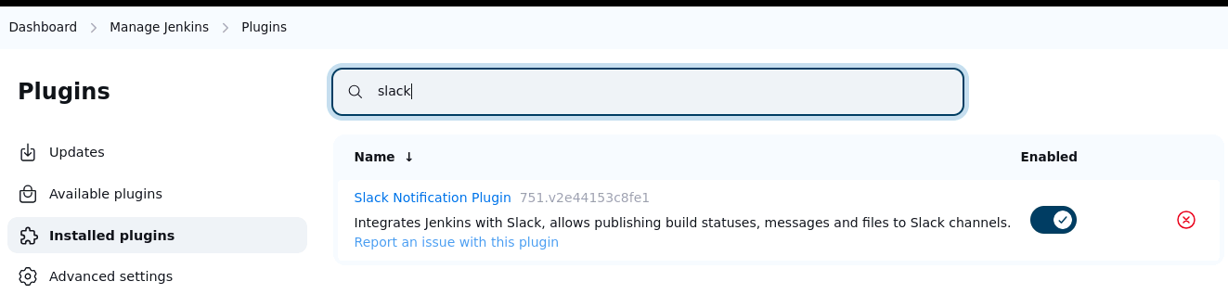

1. Created a slack channel and installed Jenkins CI App

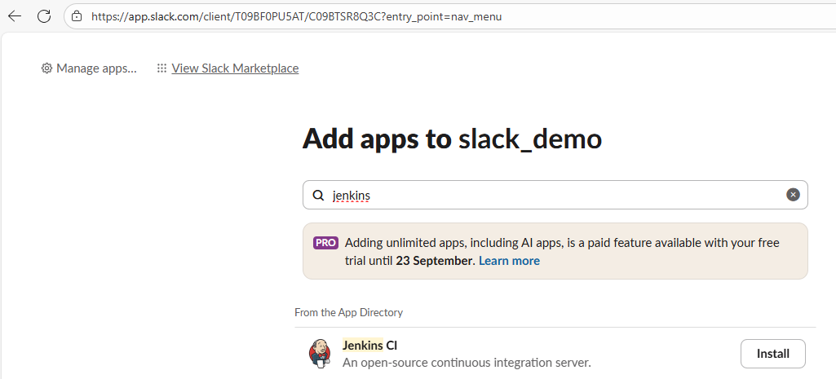

1. And added to slack_demo

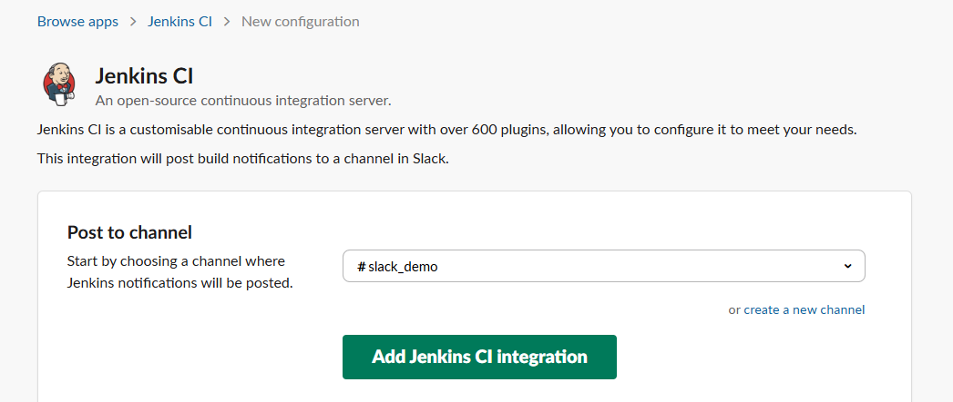

1. In Jenkins added the slack channel and tested to Success

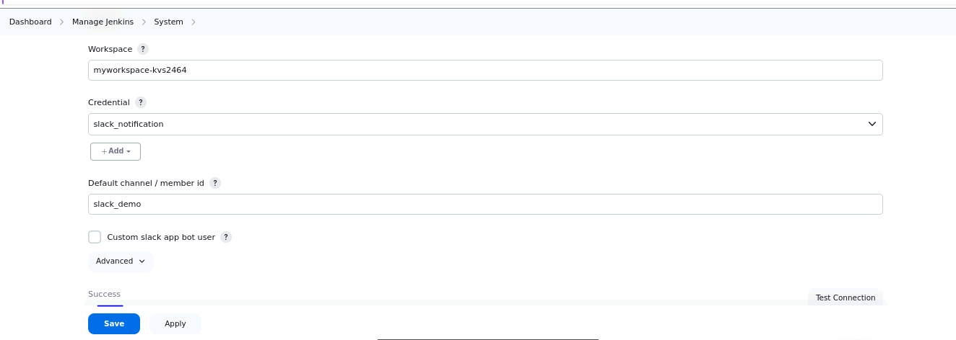

1. And got notification from slack

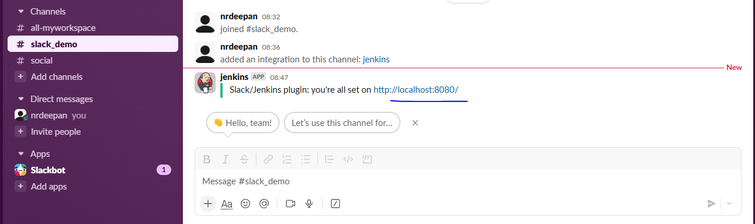

1. Configured slack_demo by adding a git project

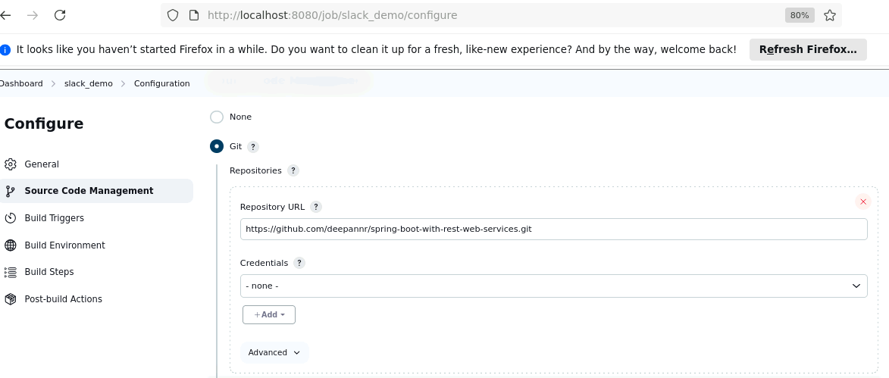

1. Configured Slack Notifications

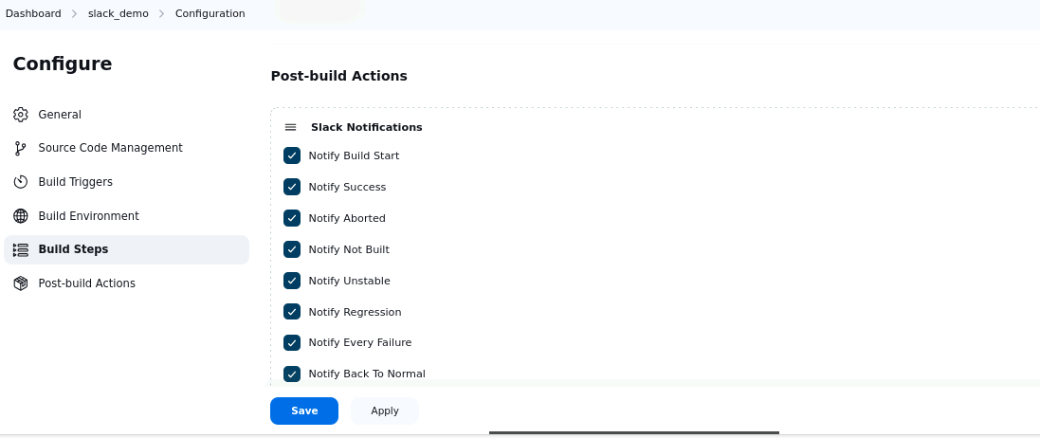

1. Build got success

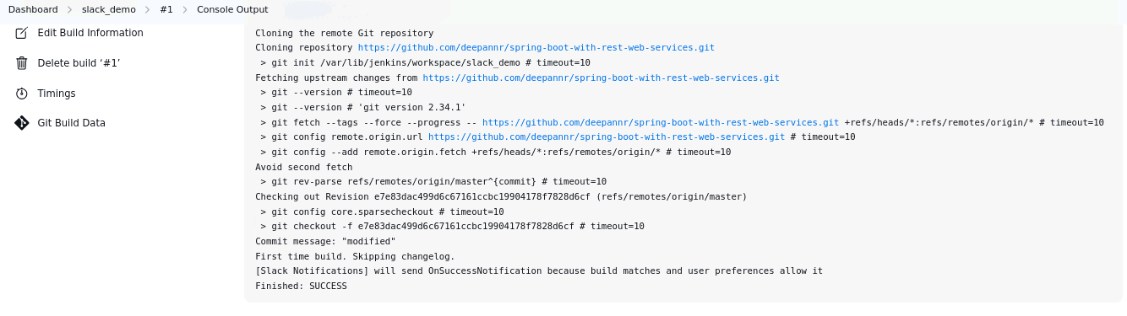

1. On the slack channel able see the notification in slack

